**Definition: Download and install Figma and give an overview about dashboard.**

**Solution:**

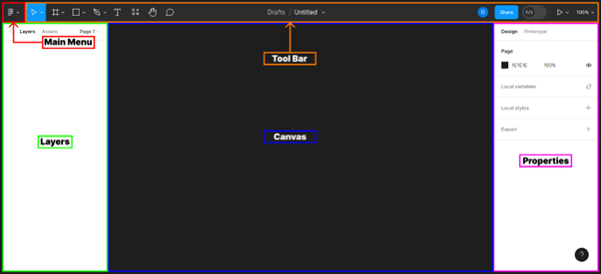

**Steps:**

* First Open Figma in browser mode.
* Then create the new document **File à New Figma Design.**
* **Main Menu: -**It contains File, Edit, View, alignment option, text etc options.
* **Toolbar: -**The tool bar located at the top of the Figma editor, provides tools like shapes, pens, text, and a frame for adding objects on the canvas and moving them around.
* **Selection Tool**
* **Frame Tool**
* **Section Tool**
* **Slice Tool**
* **Shape Tool**
* **Move tool**
* **Frame tool**
* **Pen tool**
* **Pencil tool**
* **Draw Tool**
* **Text Tool**
* **Hand Tool**
* **Comment Tool etc...**
* **Layers: -**The layers panel is located on the left side of the Figma editor. Any object that is added to the canvas is considered a layer. Frames, shapes, text, and images are all considered layers.
* **Canvas: -**The grey area in the middle of the Figma editor is the canvas. This is where you create and review all your work.
* **Properties: -**The properties panel is located on the right side of the Figma editor, it provides options for adjusting and manipulating the properties of layers that have been added to the canvas.
* The toolbar contains a variety of tools and functions. What appears in the toolbar depends on what you have selected on the canvas.
* There are many basic tools available in Figma for creating an easy user interface.
* Now, Go to the **Export** button in the property panel. And **Export** it with .**JPG/.PNG** format.